Alumno: Valentin Ragusa

Legajo: VINF016492

**Gráfico del modelo de grafos basado en el problema**

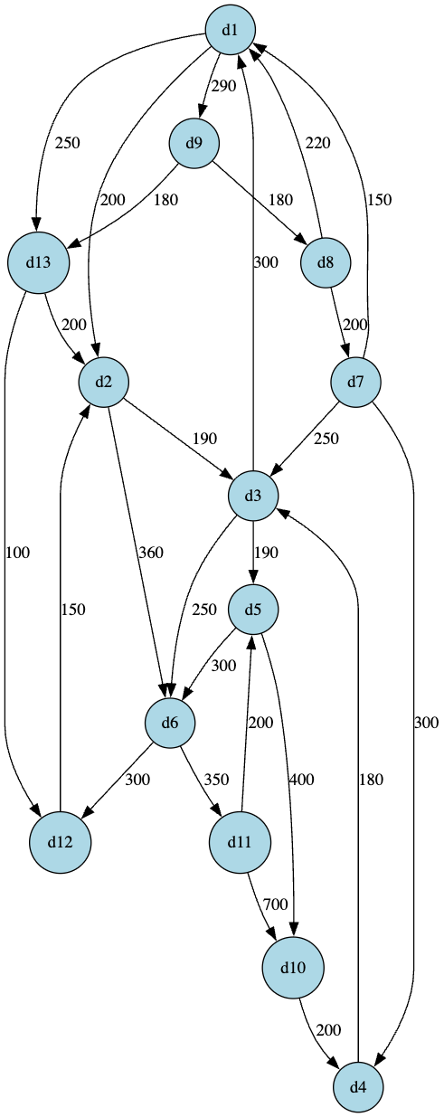

El gráfico fue hecho con Graphviz Online utilizando el siguiente código:  
  
digraph GoodFly {

rankdir=TB;

node [shape=circle, style=filled, fillcolor=lightblue];

d1 -> d2 [label="200"];

d1 -> d13 [label="250"];

d1 -> d9 [label="290"];

d2 -> d3 [label="190"];

d2 -> d6 [label="360"];

d3 -> d1 [label="300"];

d3 -> d5 [label="190"];

d3 -> d6 [label="250"];

d4 -> d3 [label="180"];

d5 -> d6 [label="300"];

d5 -> d10 [label="400"];

d6 -> d11 [label="350"];

d6 -> d12 [label="300"];

d7 -> d1 [label="150"];

d7 -> d3 [label="250"];

d7 -> d4 [label="300"];

d8 -> d1 [label="220"];

d8 -> d7 [label="200"];

d9 -> d8 [label="180"];

d9 -> d13 [label="180"];

d10 -> d4 [label="200"];

d11 -> d10 [label="700"];

d11 -> d5 [label="200"];

d12 -> d2 [label="150"];

d13 -> d2 [label="200"];

d13 -> d12 [label="100"];

}

https://dreampuf.github.io/GraphvizOnline/?engine=dot#digraph%20GoodFly%20%7B%0D%0A%20%20rankdir%3DTB%3B%0D%0A%20%20node%20%5Bshape%3Dcircle%2C%20style%3Dfilled%2C%20fillcolor%3Dlightblue%5D%3B%0D%0A%0D%0A%20%20d1%20-%3E%20d2%20%5Blabel%3D%22200%22%5D%3B%0D%0A%20%20d1%20-%3E%20d13%20%5Blabel%3D%22250%22%5D%3B%0D%0A%20%20d1%20-%3E%20d9%20%5Blabel%3D%22290%22%5D%3B%0D%0A%0D%0A%20%20d2%20-%3E%20d3%20%5Blabel%3D%22190%22%5D%3B%0D%0A%20%20d2%20-%3E%20d6%20%5Blabel%3D%22360%22%5D%3B%0D%0A%0D%0A%20%20d3%20-%3E%20d1%20%5Blabel%3D%22300%22%5D%3B%0D%0A%20%20d3%20-%3E%20d5%20%5Blabel%3D%22190%22%5D%3B%0D%0A%20%20d3%20-%3E%20d6%20%5Blabel%3D%22250%22%5D%3B%0D%0A%0D%0A%20%20d4%20-%3E%20d3%20%5Blabel%3D%22180%22%5D%3B%0D%0A%0D%0A%20%20d5%20-%3E%20d6%20%5Blabel%3D%22300%22%5D%3B%0D%0A%20%20d5%20-%3E%20d10%20%5Blabel%3D%22400%22%5D%3B%0D%0A%0D%0A%20%20d6%20-%3E%20d11%20%5Blabel%3D%22350%22%5D%3B%0D%0A%20%20d6%20-%3E%20d12%20%5Blabel%3D%22300%22%5D%3B%0D%0A%0D%0A%20%20d7%20-%3E%20d1%20%5Blabel%3D%22150%22%5D%3B%0D%0A%20%20d7%20-%3E%20d3%20%5Blabel%3D%22250%22%5D%3B%0D%0A%20%20d7%20-%3E%20d4%20%5Blabel%3D%22300%22%5D%3B%0D%0A%0D%0A%20%20d8%20-%3E%20d1%20%5Blabel%3D%22220%22%5D%3B%0D%0A%20%20d8%20-%3E%20d7%20%5Blabel%3D%22200%22%5D%3B%0D%0A%0D%0A%20%20d9%20-%3E%20d8%20%5Blabel%3D%22180%22%5D%3B%0D%0A%20%20d9%20-%3E%20d13%20%5Blabel%3D%22180%22%5D%3B%0D%0A%0D%0A%20%20d10%20-%3E%20d4%20%5Blabel%3D%22200%22%5D%3B%0D%0A%0D%0A%20%20d11%20-%3E%20d10%20%5Blabel%3D%22700%22%5D%3B%0D%0A%20%20d11%20-%3E%20d5%20%5Blabel%3D%22200%22%5D%3B%0D%0A%0D%0A%20%20d12%20-%3E%20d2%20%5Blabel%3D%22150%22%5D%3B%0D%0A%0D%0A%20%20d13%20-%3E%20d2%20%5Blabel%3D%22200%22%5D%3B%0D%0A%20%20d13%20-%3E%20d12%20%5Blabel%3D%22100%22%5D%3B%0D%0A%7D%0D%0A